4th September 2018.

To: Each Member of the Joint Policing Committee.

Re: Meeting of the Joint Policing Committee

Dear Member,

I wish to inform you that the next meeting of the Joint Policing Committee will take place in the Council Chamber, Aras an Chontae, Great Water Street, Longford, on
Monday, 10th September 2018 at 3.00 p.m.

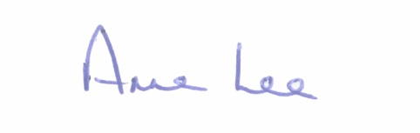
Yours sincerely,

___________________
Anne Lee,
Administrative Officer.
AGENDA

1. Confirmation of Minutes of Joint Policing Committee meetings held on the
11th June 2018 - enclosed.

2. Matters arising.
3. Garda Report.
4. Local Authority Report.
5. Update on CCTV.
6. Update on Longford Joint Action Plan.
7. Arrangements for 2018 Public Meeting.
8. Date of next meeting - 3rd December 2018.

